**Installation of Puppet**

Following are the steps to install Puppet:-

1. Install Puppet Master and Puppet Agent
2. Edit hosts and Puppet configuration files in Puppet Master and Agent
3. Establish a Secure Connection between Puppet Master and Puppet Agent

**Prerequisites:**

I am using two virtual images, so you can select any one of them as Puppet Master and other can be termed as Puppet Agent.

First, we need to delete all firewall rules from **Puppet Master** and **Puppet Agent**. Iptables is the default firewall available in the most Linux distributions by default.

Execute this: command of both **Puppet Master** and **Puppet Agent machine(vm).**

|  |  |
| --- | --- |
| 1 | iptables -F |

Now we need to save these configurations.

Execute this:

|  |  |
| --- | --- |
| 1 | service iptables save |

We need to enable the official Puppet Labs collection repository in both Puppet Master and Puppet Agent. To get this repository go to a link [***yum.puppetlabs.com***](http://yum.puppetlabs.com/)***.***

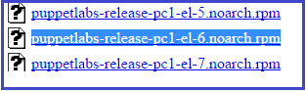Here, copy the link location of the repository according to the version.

Now to get this repository, execute the below command in both the virtual images:

Execute this:command of both **Puppet Master** and **Puppet Agent machine(vm).**

|  |  |
| --- | --- |
| 1 | rpm -ivh http://yum.puppetlabs.com/puppetlabs-release-el-6.noarch.rpm |

**PUPPET MASTER MACHINE**

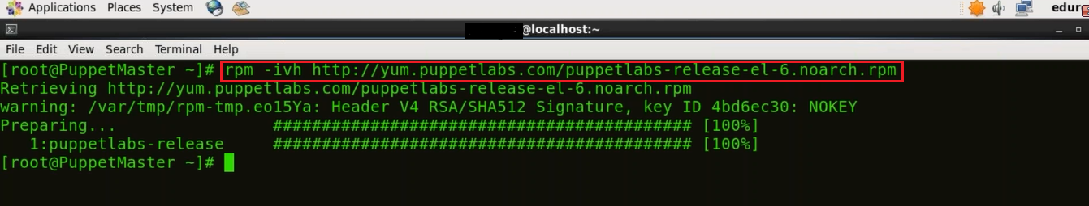

**PUPPET AGENT MACHINE**

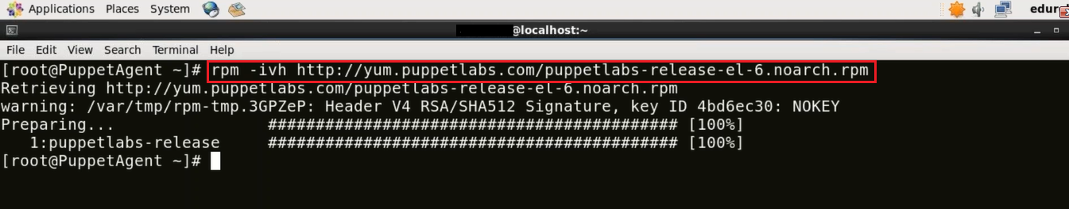

**1. Install Puppet Master and Puppet Agent**

**1.1. Install Puppet Master**

To install **Puppet Master** execute the below command:

Execute this (on **master**):

|  |  |
| --- | --- |
| 1 | yum install puppet-server |

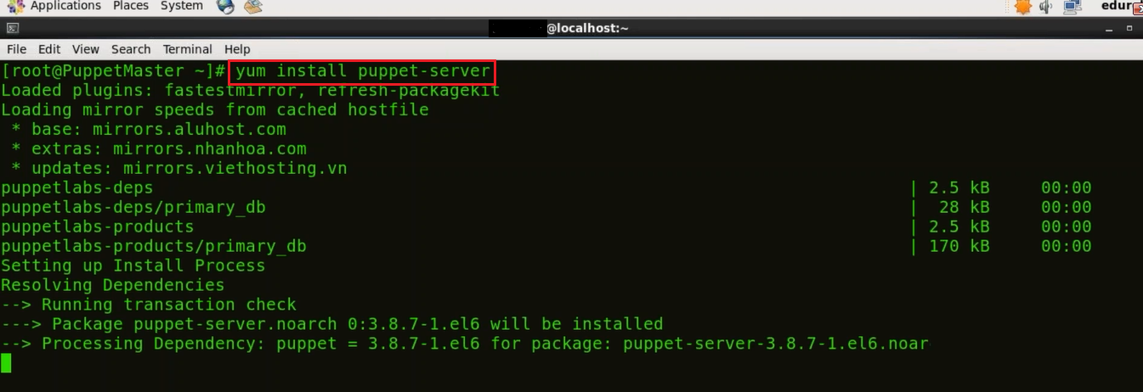

**1.2. Install Puppet Agent**

To Install **Puppet Agent** execute the below command:

Execute this (on **agen**t):

|  |  |
| --- | --- |
| 1 | yum install puppet |

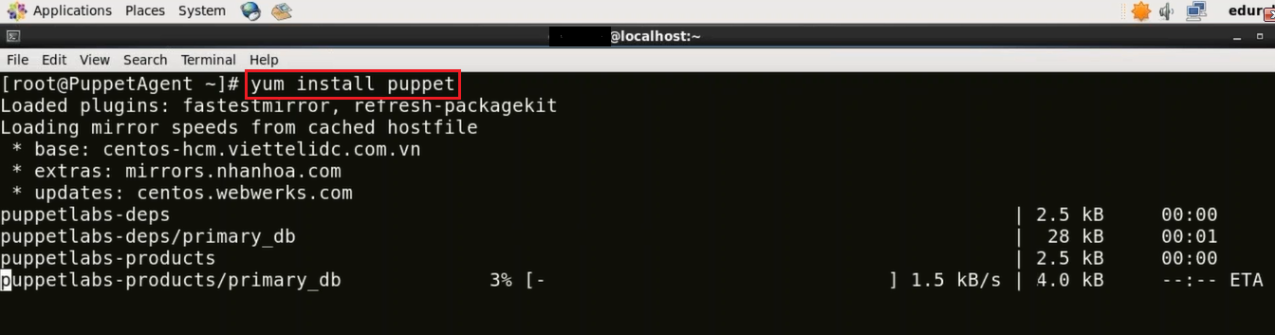

**2. Edit hosts and Puppet configuration files in Puppet Master and Agent**

**2.1. Edit hosts and Puppet configuration files in Puppet Master**

First, in Puppet Master virtual image I will edit the hosts file using **vi editor**. You can use any other editor like **vim**, **gedi**t etc. as well.

Execute this (on **master**):

|  |  |
| --- | --- |
| 1 | vi /etc/hosts |

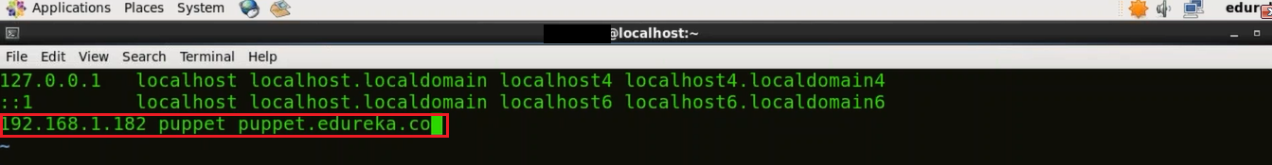

Just type the IP address of your machine and give a domain name to it. In the above screenshot you can see that 192.168.1.182 is the IP address of my machine and I have assigned it a domain name ***puppet puppet.edureka.co***.

In order to know the IP address of your machine use the below command:

Execute this (on **master**):

|  |  |
| --- | --- |
| 1 | ifconfig |

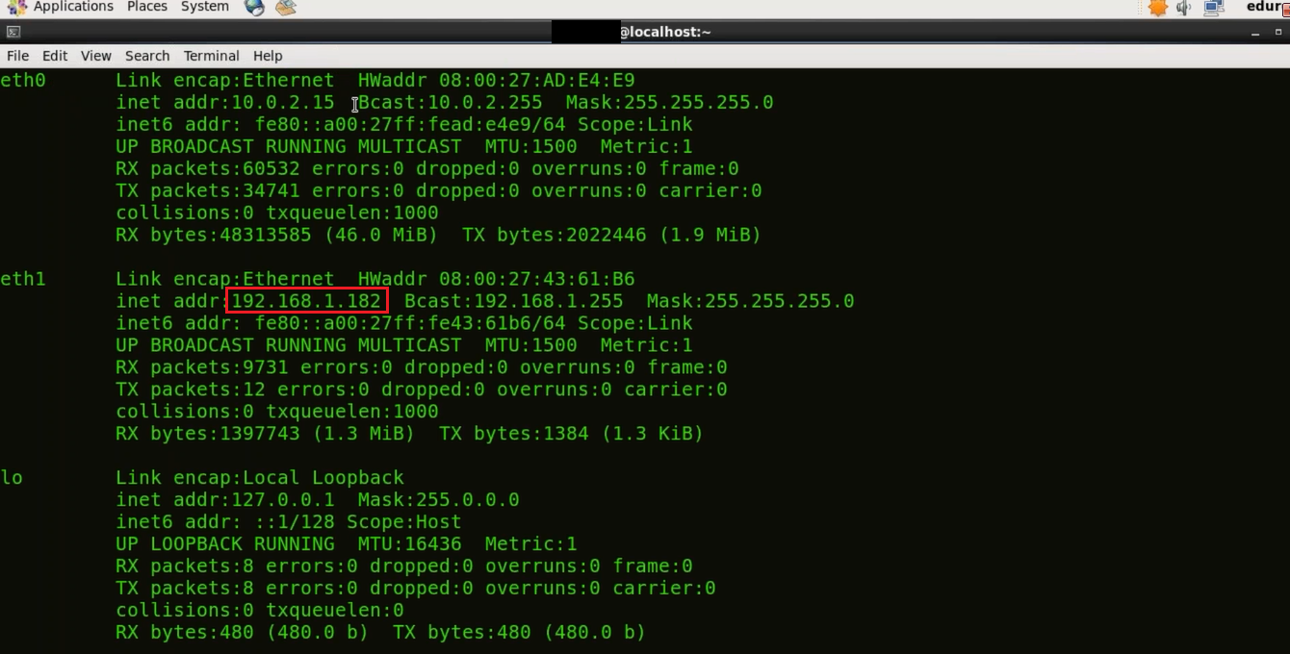

Now we will edit the Puppet configuration file, I will use **vi** editor.

Execute this (on **master**):

|  |  |
| --- | --- |
| 1 | vi /etc/puppet/puppet.conf |

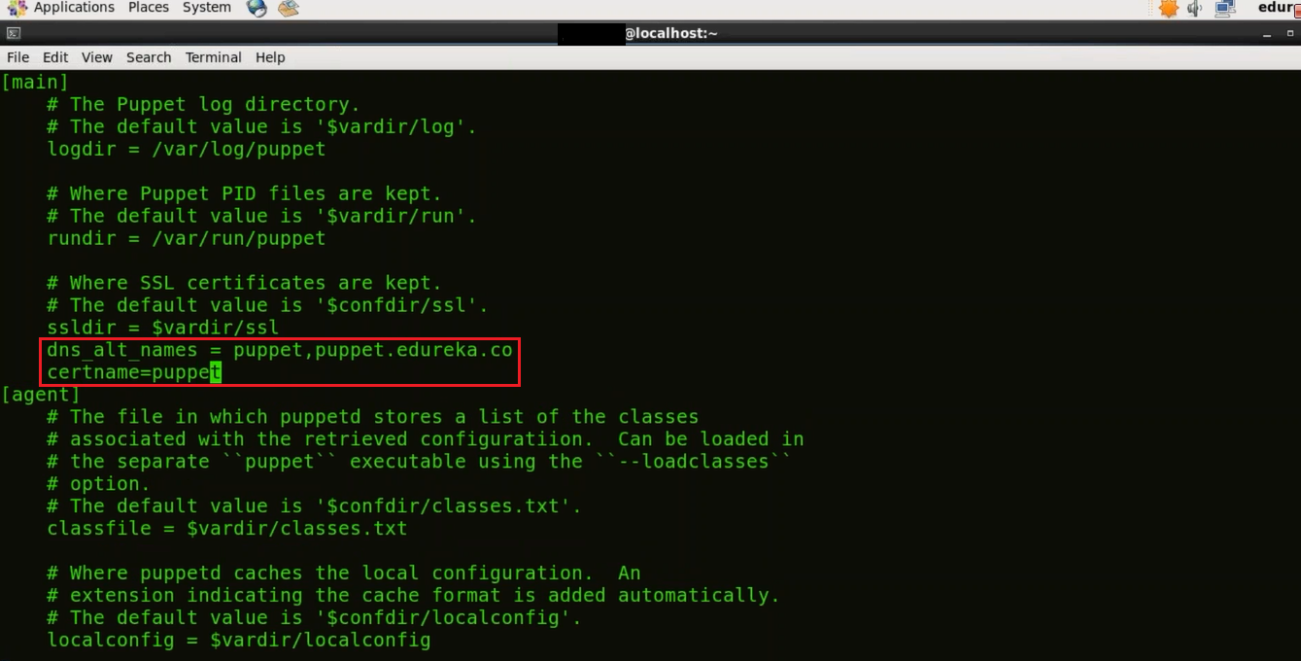

Here in the Master section give the DNS name to which the server will respond to (type the domain name that you have given to your Puppet Master). DNS is an important element to ensure that nodes communicate using friendly names instead of IP addresses.

***dns_alt_names = puppet,puppet.edureka.co***

We need to give the certificate name as well

***certname=puppet***

**2.2.Edit hosts and Puppet configuration files in Puppet Agent**

Similar to Puppet Master here in the Puppet Agent virtual image we will first edit the hosts file by using vi editor.

Execute this (on **agent**):

|  |  |
| --- | --- |
| 1 | vi /etc/hosts |

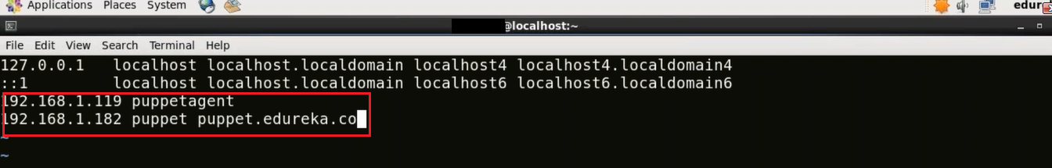

Now type the IP address of your Puppet Agent and give a domain name to it, I have given ‘***puppetagent*’**. You also need to give the IP address of your Puppet Master and the domain name attached to it.

*192.168.1.119****puppetagent*** *192.168.1.182* ***puppet puppet.edureka.co*** *(****puppet master machine****)*

Let us now edit the Puppet configuration file.

Execute this (on **agent**):

|  |  |
| --- | --- |
| 1 | vi /etc/puppet/puppet.conf |

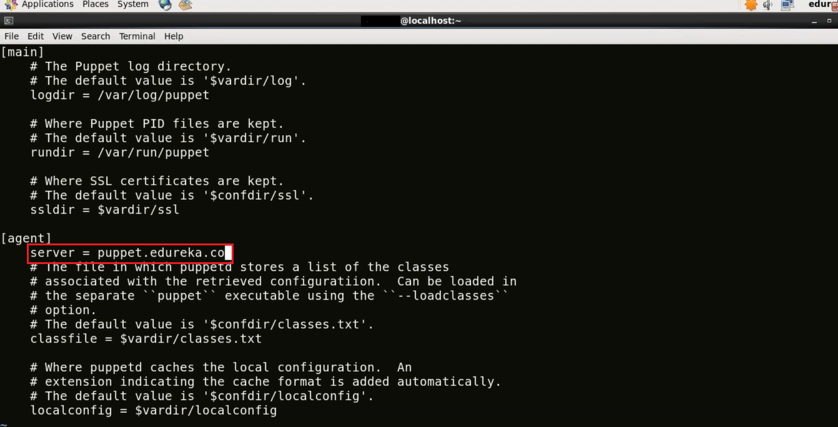

Now in the agent section assign the server name.  
Type the domain name of your Puppet Master. This is a very important step because once you give the domain name it will go to the hosts file and check the IP address attached to that domain name. Make sure you have typed the correct domain name.

***server = puppet.edureka.co***

**3. Establish A Secure Connection Between Puppet Master and Puppet Agent**

Puppet Agent requests Puppet Master for its certificate. Once Puppet Master sends its certificate Puppet Agent generates its own certificate. It then requests the Puppet Master to sign this certificate. Once Master has signed this certificate there is a secure connection established between Puppet Master and Puppet Agent.

**3.1. Generate Puppet Master Certificate**

In Puppet Master virtual image, in order to generate CA certificate and Puppet Master certificate in Puppet Master machine execute the below command:

Execute this (on **master**):

|  |  |
| --- | --- |
| 1 | sudo -u puppet puppet master --no-daemonize --verbose |

This command will create the CA certificate and a Puppet Master certificate, with the appropriate DNS names included. Stop It once the version of Puppet is displayed by using **ctrl+c** because we cannot start the Puppet Master right now.

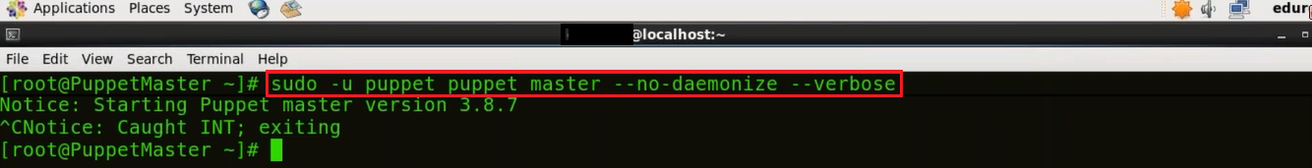

Now I will start **Puppet Master**.

Execute this (on master):

|  |  |
| --- | --- |
| 1 | puppet resource service puppetmaster ensure=running |

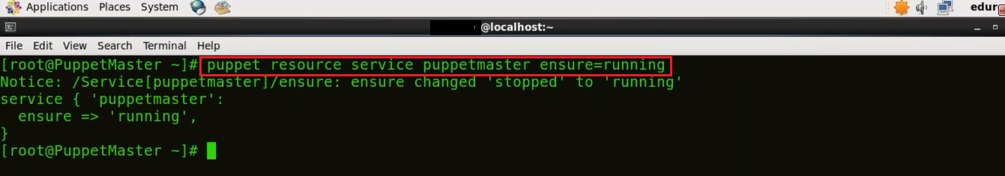

**3.2. Send Certificate signing request from Puppet Agent to Puppet Master**

Here in **Puppet Agent** virtual image, I need to send the certificate signing request to Puppet Master.

Execute this (on **agent**):

|  |  |
| --- | --- |
| 1 | puppet agent -t |
|  |  |

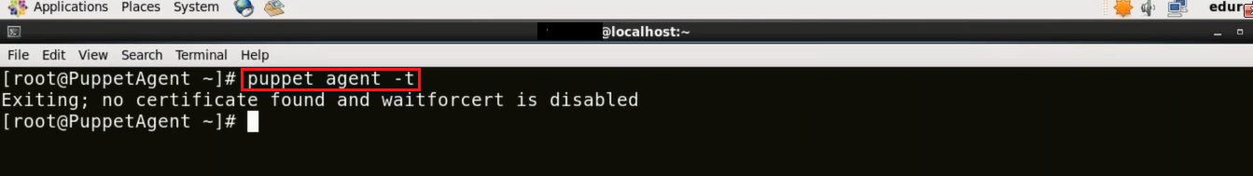

**3.3. Sign Puppet Agent Certificate in Puppet Master**

In Puppet Master virtual image, we need to sign the certificate requested by Puppet Agent. In order to get the list of certificates execute the below command:

Execute this (on **master**):

|  |  |
| --- | --- |
| 1 | puppet cert list |

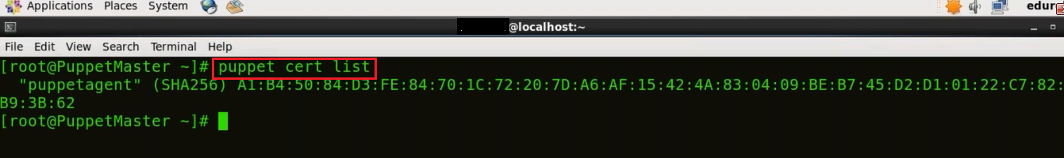

As you can see that there is a certificate signing request pending by the name **puppetagent**. In order to sign that certificate execute the below command:

Execute this (on **master**):

|  |  |
| --- | --- |
| 1 | puppet cert sign puppetagent |
|  |  |
|  |  |

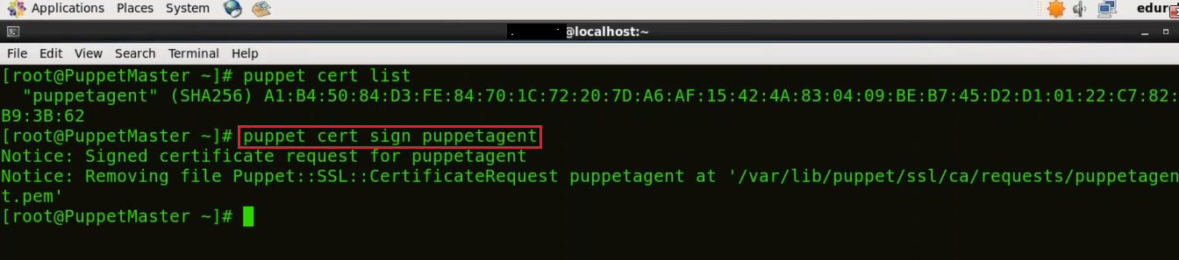

Here the certificate signing request was sent by **Puppet Agent** so I have signed that particular certificate, refer the screenshot above.

**3.4. Update Puppet Agent**

First, we need to start the Puppet Agent.

Execute this (on **agent**):

|  |  |
| --- | --- |
| 1 | puppet resource service puppet ensure=running |

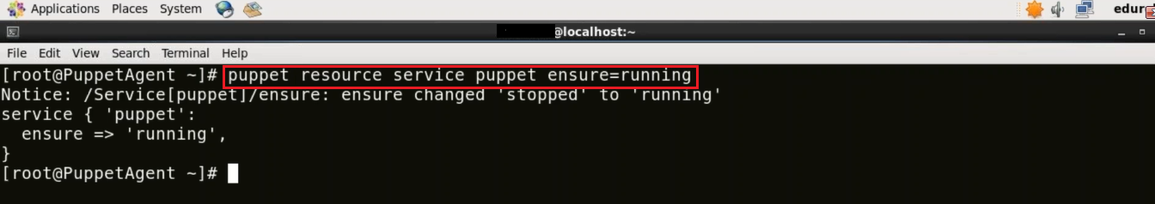

Now we need to update the **Puppet** **Agent** with the changes made in the **Puppet Master**. Since the Master has recently signed the certificate so it will update that.

Execute this (on **agent**):

|  |  |
| --- | --- |
| 1 | puppet agent -t |
|  |  |

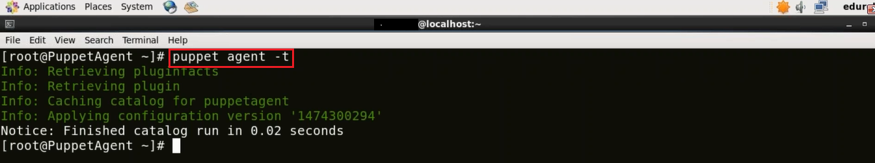

**Congratulations!** Now there is a secure connection between Puppet Master and Puppet Agent. Let us now see a Puppet example, in which I will deploy Apache Tomcat using Puppet.